Student’s Name:

Student’s Number:

Instructor’s Name:

Course Name:

Date:

- 82-year-old diabetic male reports were losing 12 lbs. over the last month.

S: He'll lose 12 lbs. During the last month,
HPI

Onset: last month, last month

Place: Popularized

Period: 12 Pounds. During the last month,

Characteristic: A deliberate loss of weight? Modified diet? Will there be any low mood? Huh? Nausea? About vomiting?

Factors that are aggravating: any stress factors? Does it cause nausea due to the smell of food? Any swallowing problems or problems with dental implants? Any drugs that cause bad taste?

Factors relieving: attempting small meals? A soft meal? Looking for an uninteresting meal?

Diagnosis: taking any supplements for meals? About any vitamins? Any drugs to boost your cravings?

Intensity: 12-lb loss. During the last month,

PH: DM, ask if the patient has a history of psychiatry, ask for any sculptor, past medical history, genetic predisposition, past medical history of the family, cause of death.
Social History: Tobacco, alcohol, drug use questions
Allergies: ask about allergies to medication, the environment, and food. Apply reaction
Medications: ask about medicines for routine and OTC, dosage, frequency, and reason for
Treatment with medication. Some medicines may cause your appetite to decrease.
Immunizations: ask about the status of immunizations (last TD, pneumococcal, flu, and zoster vaccine)

ROS:
General: diet change, fever, shivers, lack of strength, night sweats, tiredness, feelings of forgetfulness?
HEENT: showing any symptoms of URI, traveling outside the nation, any ill contact? Sneezing after drinking or eating? Difficulty swallowing or a shocking sensation? Losing flavor? Any pain from the gum? Difficulty chewing? Dentures presence? Need dentures or a substitute?
Cardiac: any pain in your chest, irritation, or tachycardia?
Circulatory: any sniffle, chest congestion, difficulty, or shortness of breath?
GI: any pain or discomfort in the abdomen, LBM, indigestion, indigestion, n/v? Yeah, color and
Coherence, severity?
GU: any urination burns or discomfort? Unable to be devoid, or starting to feel that incontinence takes too long? The smell, color?
Disk herniation: on each side of the limbs, having experienced any weakness? Loss of cooperation or equilibrium?
O:
Physical Assessment
Overall: explains the patient's appearance today, reliability in history, vitals, discomfort or chills request, recent journeys. Difficulty with food, cooking, economic problems or issues, parental support, living standards, meal preparation assistance, cleaning, and ADLs.

HEENT: assess expression, defects, or volumes. Investigate for any trauma involvement. Inspect cavity, sweet tooth, discomfort, or painfully orally. Any sight or listening loss factors
Cardiac: Auscultate cardiac arteries for abnormal condition and elevated rate and bruise and pédagogie carotid arteries. EKG is suitable for heart rhythm assessment because of its age
Airborne function: test lung function, breathing history, CXR for opacity or penetration related to possible pneumonia, disease, or malignancy
GI: Renal dysfunction assessment, GI bleeding risk, or GI anomalies might worsen with a care plan.
Hematology: an examination of anomalies of coagulopathy, history of the bleeding syndrome
GU: check for any swelling, release, pain, discomfort, or mass, perfuse the bladder for potential retention and expand the prostate. Urinalysis order r/o UTI, hemoptysis, and if successful, submit science and tolerance samples.
Musculoskeletal: test the hemiparesis, intensity, and any factor linked to feeding problems
Neuro: cognition status assessment, migraine, blurry vision, pain. Assess failure to record, react or stimulate

Dx Inability to develop weight loss syndrome, declining appetite, and inactivity, frequently with fatigue, symptoms of depression compromised immune function, and cholesterol levels. It is a deterioration of physical weakness in older adults that is often exacerbated by cognitive disability and functional impairment (Agarwal, 2018).
o Optimistic pertinent: weight loss 12 Lbs. From the last span
o Specific negative: no present
Differential Dx Pancreatic cancer: The underlying factors that support the progression of diabetes-related pancreatic cancer were insulin resistance and related hypoglycemia, hyperinsulinemia, and inflammation. Signaling pathways that govern the metabolism also play an essential role in cancer growth and tumors (De Souza, Irfan, Masud, Saif, 2016).
o Optimistic pertinent: loss of weight 12 Lbs. In the last month
o Specific pessimistic: no current
Differential Dx TIA: Certain older adults who live alone can not tell anyone what is happening and what will happen, usually in mild cases. And patients decide to stay home because "symptoms are gone" from personal experience with a patient.
o Optimistic pertinent: 12 lbs weight loss. In the last month
o Negative apt: none
Other portion of the body with Differential Dx malignancy. Therefore, more studies are required to investigate why weight loss is unintentional
o Positive percentage: 12 lbs weight loss. In the last month
o Specific negative: none

P: 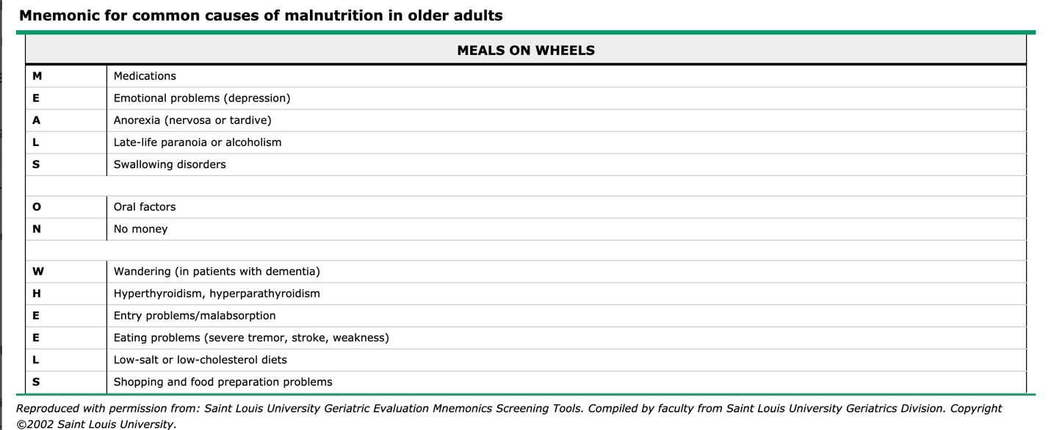
Treatment Plan
o Physical examination complete, including PHQ9 questionnaire
o CMP, Hepatic panel differential CBC, Calcium, B12, vitamin D, albumin, cholesterol total, 25 (OH), vitamin D Phosphate, TSH, folate number (Agarwal, 2018).
o Urinalysis and sending specimen for C/S if UTI is positive
o CXR for fungus, tube, or malignancy evaluation (Agarwal, 2018)
o EKG for rhythmic or MI assessment (Agarwal, 2018)
o CRP, ESR. Rheumatic polymyalgia, chronic or malignant infection (Agarwal, 2018)
o Screen for HIV and syphilis in patients who have a chance (Agarwal, 2018)
o CT according to irregular results (Agarwal, 2018)
o PT and OT for patients with weakness or ADL difficulty (Agarwal, 2018)
o Consultation with dietitians to prescribe or increase appetite meal supplements
o If the patient has not sufficient family support, the social worker

Reference

Agarwal, K. (2018, May 2). Failure to thrive in older adults: Evaluation. Retrieved April 8, 2020, from https://www.uptodate.com/contents/failure-to-thrive-in-older-adults-evaluation?search=cancer in seniors&source=search_result&selectedTitle=7~16&usage_type=default&display_rank=7#H3

De Souza, A., Irfan, K., Masud, F., & Saif, M. W. (2016, March). Diabetes Type 2 and Pancreatic Cancer: A History Unfolding. Retrieved April 8, 2020, from https://www.ncbi.nlm.nih.gov/pmc/articles/PMC5860818/

Li, D. (2012, January). Diabetes and pancreatic cancer. Retrieved April 8, 2020, from https://www.ncbi.nlm.nih.gov/pmc/articles/PMC3238796/

